# 4. PROPOSED SOLUTION

## 4.1 Background

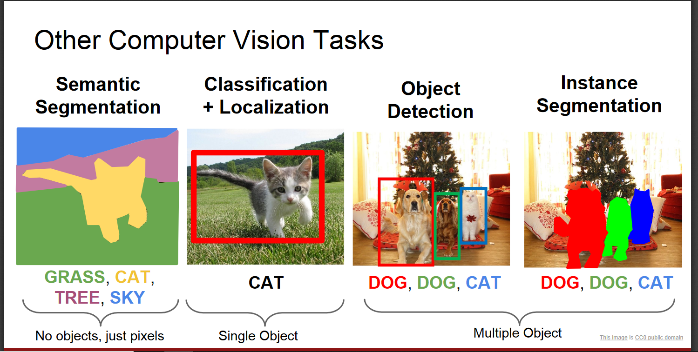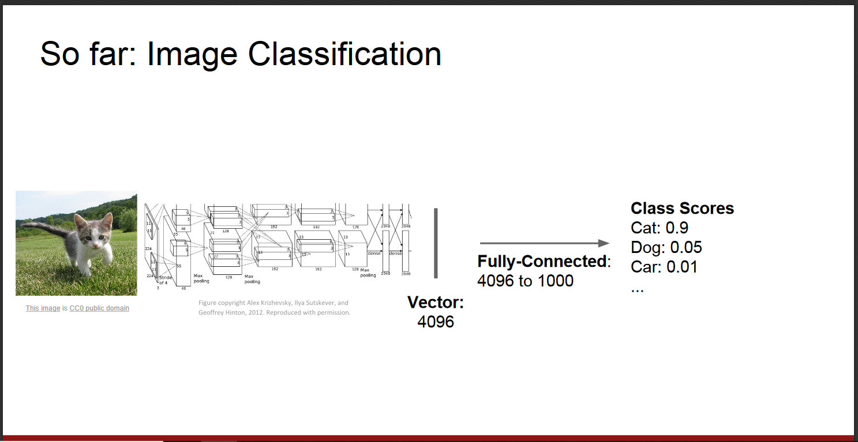Before we start let us take a look on various computer vision tasks. In the following two picture we show some of various computer vision tasks :

### 4.1.1 What is Image Classification

Image classification takes an image and predicts the object in an image. For example, when we built a cat-dog classifier, we took images of cat or dog and predicted their class:

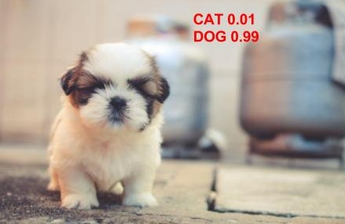

But What do you do if both cat and dog are present in the image ?



What would our model predict?!

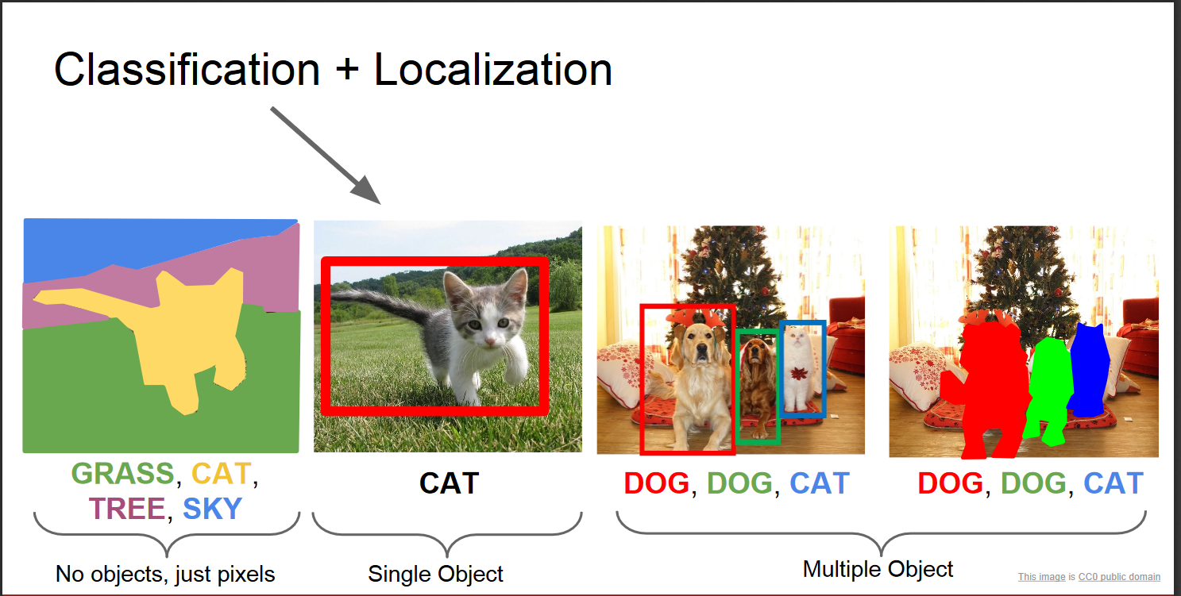To solve this problem we can train a multi-label classifier, which will predict both the classes (dog as well as cat). However, we still will not know the location of cat or dog. The problem of identifying the location of an object (given the class) in an image is called **localization**. However, if the object class is not known, we have to not only determine the location but also predict the class of each object.



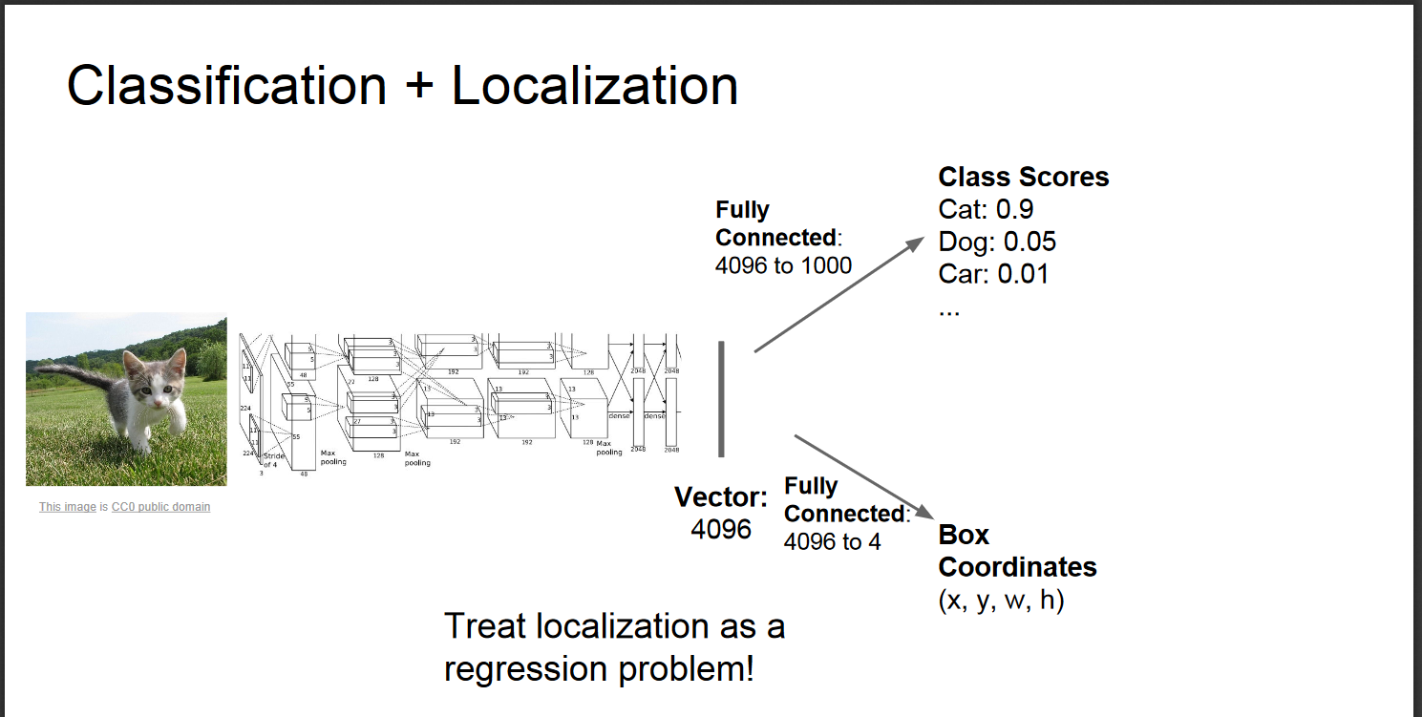

**Predicting the location of the object along with the class is called object Detection.**In place of predicting the class of object from an image, we now have to predict the class as well as a rectangle (called bounding box) containing that object. It takes 4 variables to uniquely identify a rectangle. So, for each instance of the object in the image, we shall predict following variables:

class_name

bounding_box_top_left_x_coordinate

bounding_box_top_left_y_coordinate

bounding_box_width

bounding_box_height

Just like multi-label image classification problems, we can have multi-class object detection problem where we detect multiple kinds of objects in a single image:

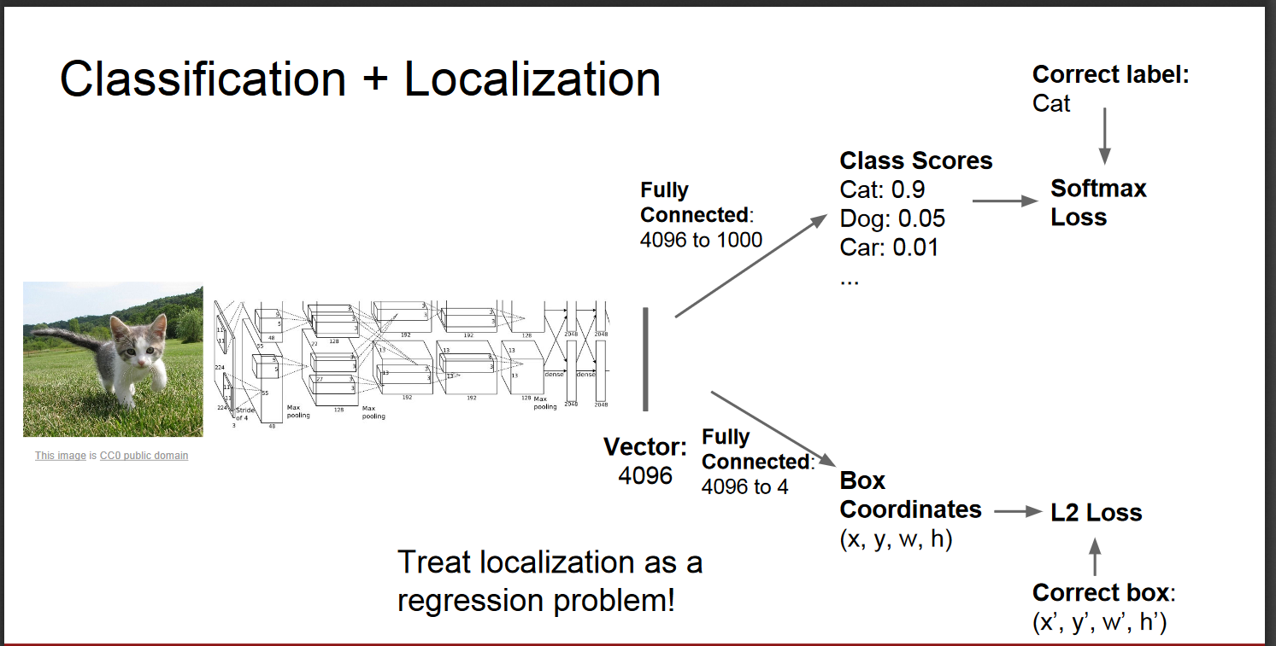

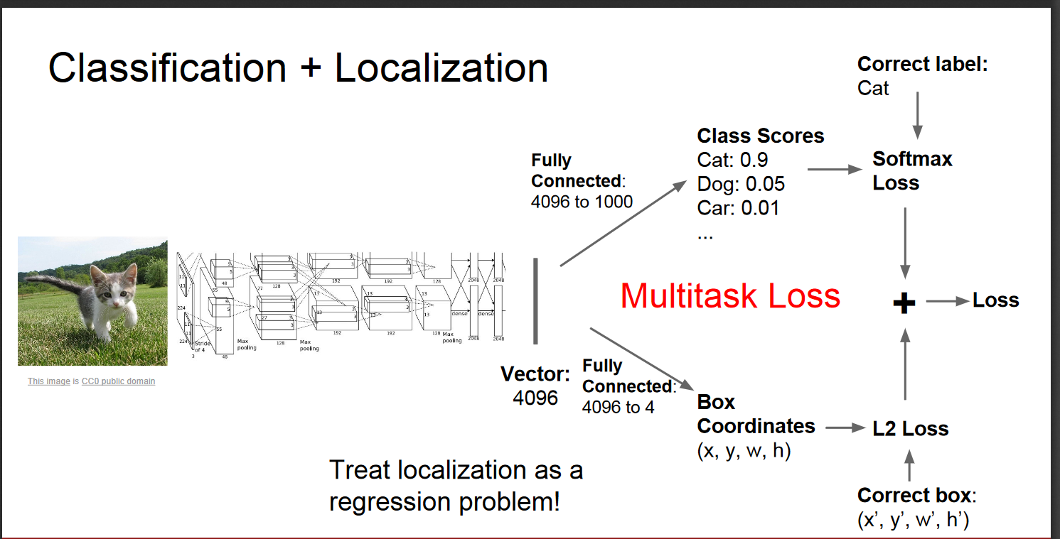

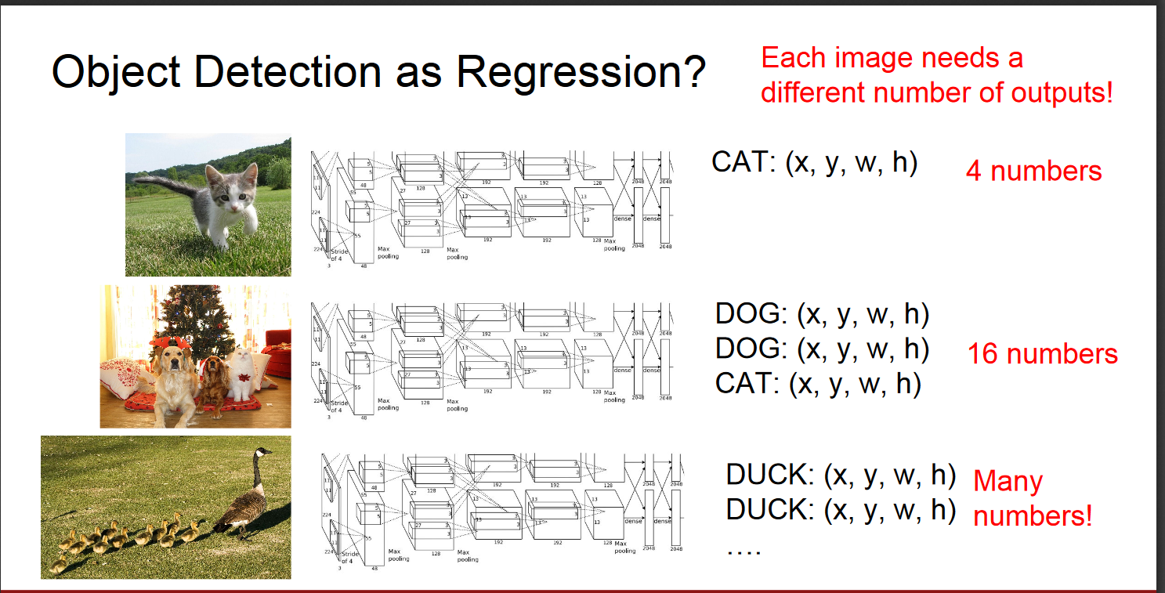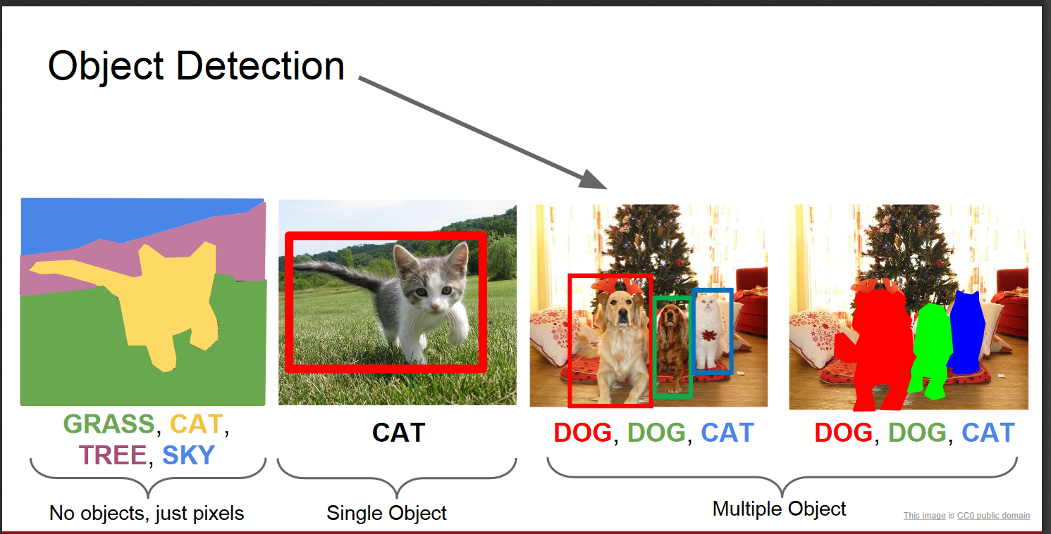

#### 4.1.2 Object Detection as a classification problem

Object Detection is modeled as a classification problem where we take windows of fixed sizes from input image at all the possible locations feed these patches to an image classifier.

Each window is fed to the classifier which predicts the class of the object in the window ( or background if none is present). Hence, we know both the class and location of the objects in the image

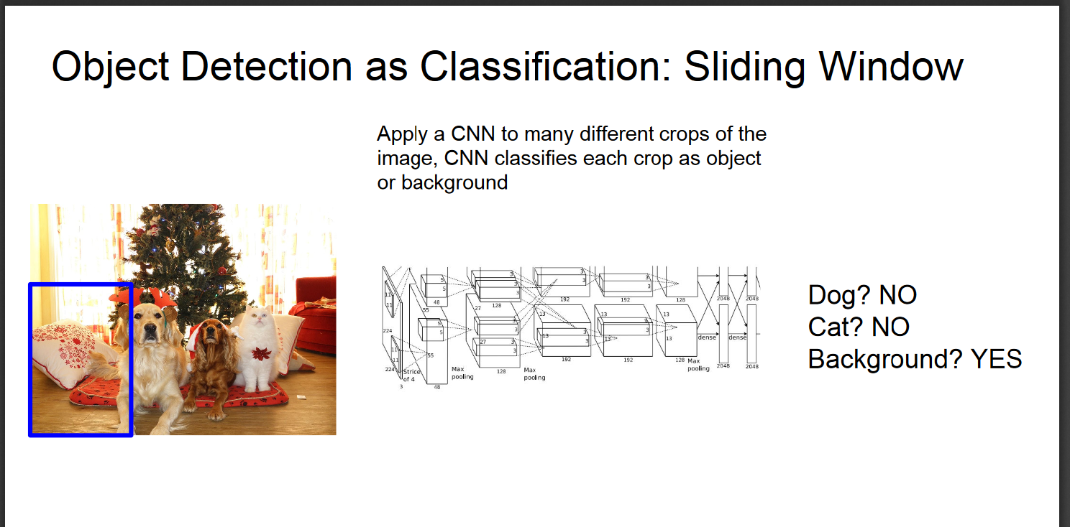

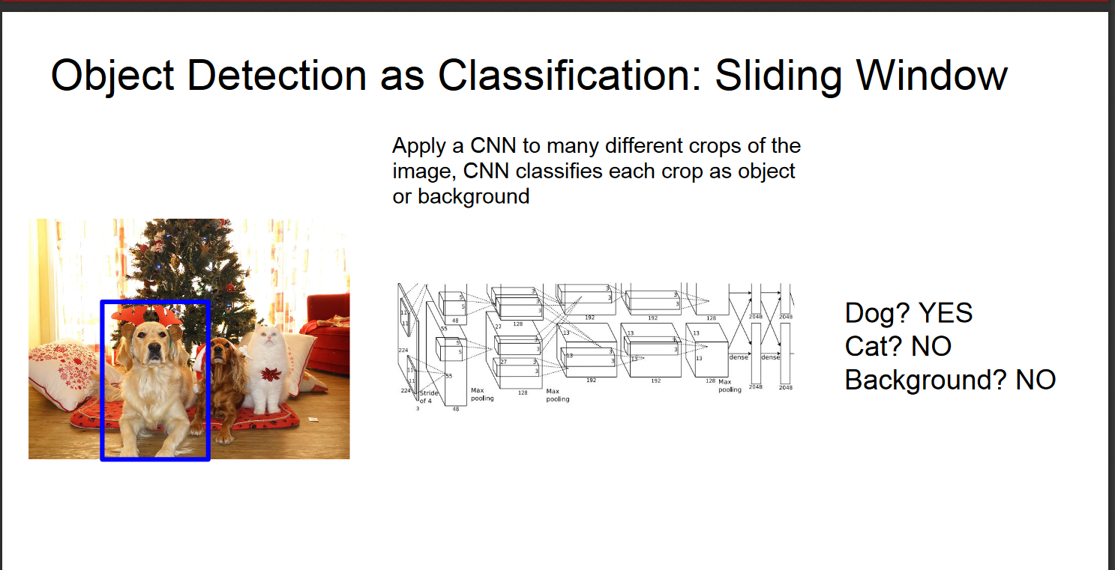Problems!

* How do you know the size of the window so that it always contains the image ?
* Need to apply CNN to huge number of locations and scales, very computationally expensive

#### 4.1.3 Region-based Convolutional Neural Networks(R-CNN):

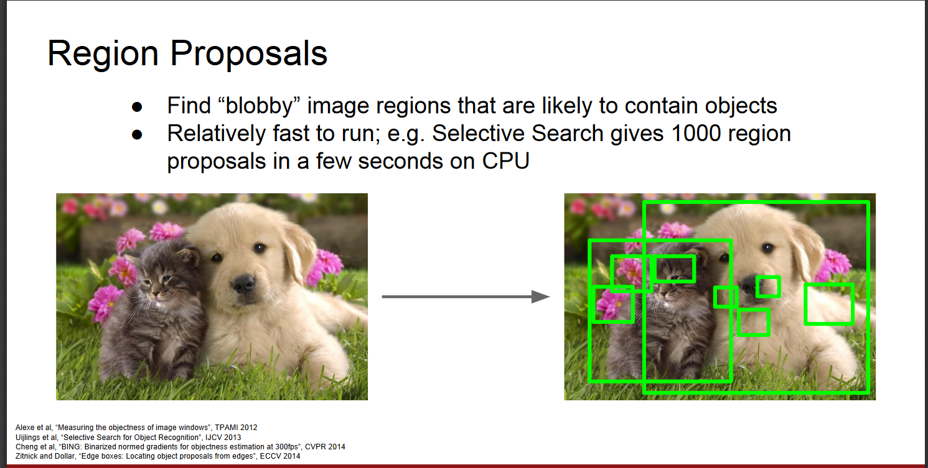Since we had modeled object detection into a classification problem, success depends on the accuracy of classification. However, there was one problem. CNNs were too slow and computationally very expensive. It was impossible to run CNNs on so many patches generated by sliding window detector. R-CNN solves this problem by using an object proposal algorithm called **Selective Search**, which reduces the number of bounding boxes that are fed to the classifier to close to 2000 region proposals. Selective search uses local cues like texture, intensity, color and/or a measure of insaneness etc. to generate all the possible locations of the object.

Now, we can feed these boxes to our CNN based classifier. Remember, fully connected part of CNN takes a fixed sized input so, we resize (without preserving aspect ratio) all the generated boxes to a fixed size (224×224 for VGG) and feed to the CNN part. Hence, there are 3 important parts of R-CNN:

1. Run Selective Search to generate probable objects.
2. Feed these patches to CNN, followed by SVM to predict the class of each patch.
3. Optimize patches by training bounding box regression separately.



R-CNN: Problems

•Ad hoc training objectives

•Fine-tune network with softmax classifier (log loss)

•Train post-hoc linear SVMs (hinge loss)

•Train post-hoc bounding-box regressions (least squares)

•Training is slow (84h), takes a lot of disk space

•Inference (detection) is slow

•47s / image with VGG16 [Simonyan & Zisserman. ICLR15]

• Fixed by SPP-net [He et al. ECCV14]

##### Spatial Pyramid Pooling ([SPP-net](https://arxiv.org/abs/1406.4729)):

Still, **RCNN was very slow**. Because running CNN on 2000 region proposals generated by Selective search takes a lot of time. SPP-Net tried to fix this. **With SPP-net, we calculate the CNN representation for entire image only once and can use that to calculate the CNN representation for each patch generated by Selective Search**. This can be done by performing a pooling type of operation on JUST that section of the feature maps of last conv layer that corresponds to the region. The rectangular section of conv layer corresponding to a region can be calculated by projecting the region on conv layer by taking into account the downsampling happening in the intermediate layers(simply dividing the coordinates by 16 in case of VGG).

**There was one more challenge**: we need to generate the fixed size of input for the fully connected layers of the CNN so, SPP introduces one more trick. **It uses spatial pooling after the last convolutional layer as opposed to traditionally used max-pooling**. SPP layer divides a region of any arbitrary size into a constant number of bins and max pool is performed on each of the bins. Since the number of bins remains the same, a constant size vector is produced as demonstrated in the figure below.



However, there was one big drawback with SPP net, it was not trivial to perform back-propagation through spatial pooling layer. Hence, the network only fine-tuned the fully connected part of the network. SPP-Net paved the way for more popular Fast RCNN which we will see next.

##### Fast R-CNN:

Fast RCNN uses the ideas from SPP-net and RCNN and fixes the key problem in SPP-net. **They made it possible to train end-to-end**. To propagate the gradients through spatial pooling,  It uses a simple back-propagation calculation which is very similar to max-pooling gradient calculation with the exception that pooling regions overlap and therefore a cell can have gradients pumping in from multiple regions.

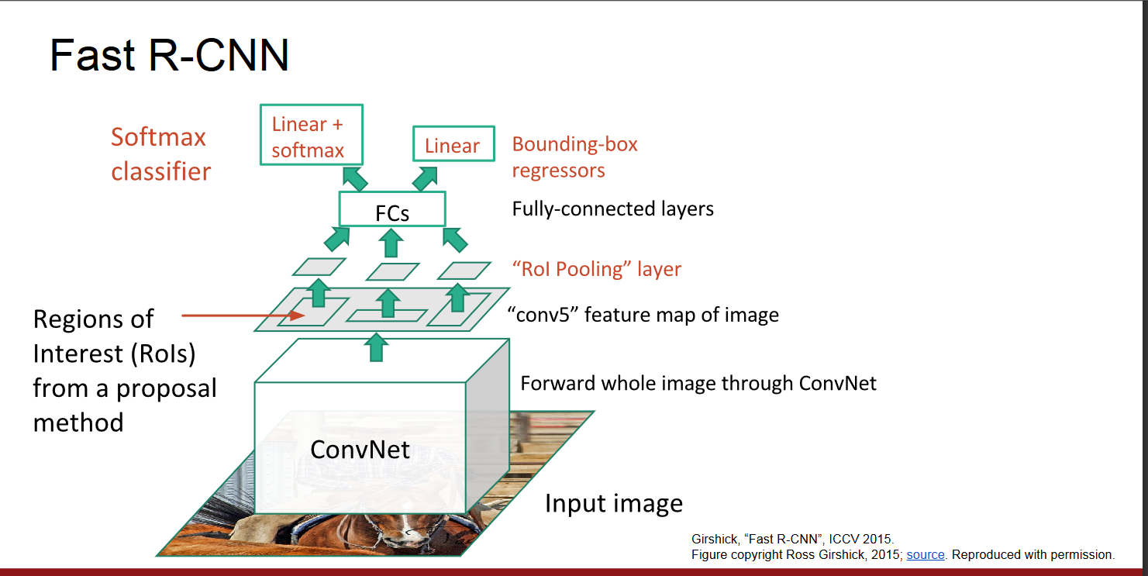**One more thing that Fast RCNN did that they added the bounding box regression to the neural network training itself.** So, now the network had two heads, classification head, and bounding box regression head. This multitask objective is a salient feature of Fast-rcnn as it no longer requires training of the network independently for classification and localization. These two changes reduce the overall training time and increase the accuracy in comparison to SPP net because of the end to end learning of CNN.

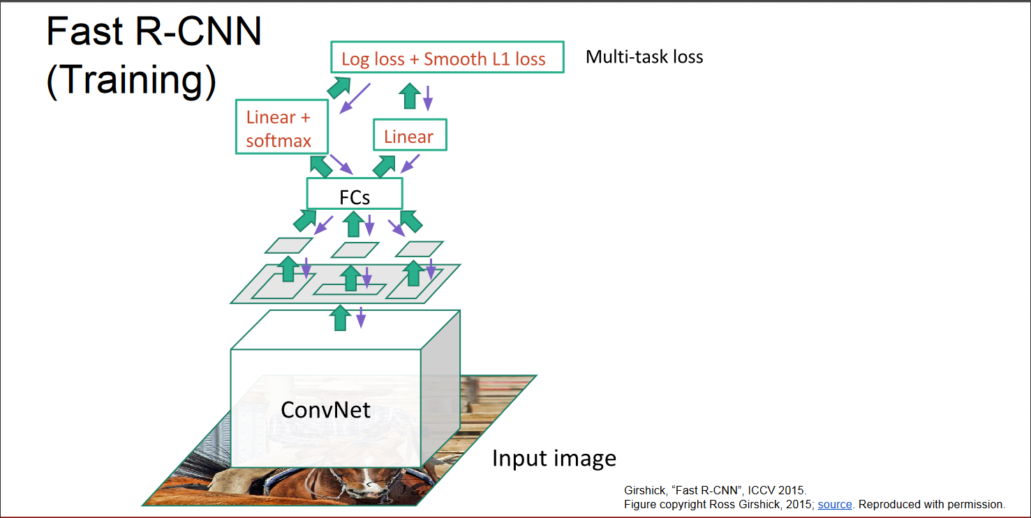

##### Faster R-CNN:

So, what did Faster RCNN improve? Well, it’s faster. And How does it achieve that? Slowest part in Fast RCNN was **Selective Search** . Faster RCNN replaces selective search with a very small convolutional network called **R**egion **P**roposal **N**etwork to generate regions of Interests.

To handle the variations in aspect ratio and scale of objects, Faster R-CNN introduces the idea of **anchor boxes**. At each location, the original paper uses 3 kinds of anchor boxes for scale 128x 128, 256×256 and 512×512. Similarly, for aspect ratio, it uses three aspect ratios 1:1, 2:1 and 1:2. So, In total at each location, we have 9 boxes on which RPN predicts the probability of it being background or foreground. We apply bounding box regression to improve the anchor boxes at each location. So, RPN gives out bounding boxes of various sizes with the corresponding probabilities of each class. The varying sizes of bounding boxes can be passed further by apply Spatial Pooling just like Fast-RCNN. The remaining network is similar to Fast-RCNN. Faster-RCNN is 10 times faster than Fast-RCNN with similar accuracy of datasets like VOC-2007. That’s why Faster-RCNN has been one of the most accurate object detection algorithms. Here is a quick comparison between various versions of RCNN.

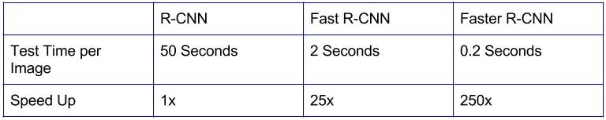

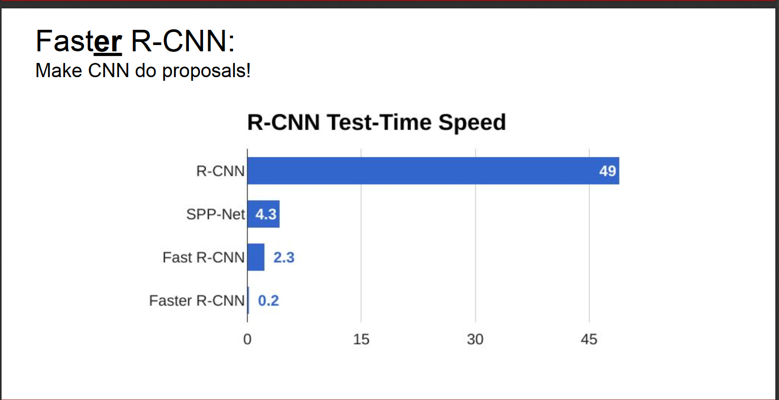

### 4.1.4 Regression-based object detectors:

So far, all the methods discussed handled detection as a classification problem by building a pipeline where first object proposals are generated and then these proposals are send to classification/regression heads. However, there are a few methods that pose detection as a regression problem. Two of the most popular ones are YOLO and SSD. These detectors are also called single shot detectors. Let us have a look at them:

##### 4.1.4.1 YOLO(You only Look Once):

For YOLO, detection is a simple regression problem which takes an input image and learns the class probabilities and bounding box coordinates. Sounds simple?

YOLO divides each image into a grid of S x S and each grid predicts N bounding boxes and confidence. The confidence reflects the accuracy of the bounding box and whether the bounding box actually contains an object(regardless of class). YOLO also predicts the classification score for each box for every class in training. You can combine both the classes to calculate the probability of each class being present in a predicted box.

So, total SxSxN boxes are predicted. However, most of these boxes have low confidence scores and if we set a threshold say 30% confidence, we can remove most of them as shown in the example below.



Notice that at runtime, we have run our image on CNN only once. Hence, YOLO is super fast and can be run real time. Another key difference is that YOLO sees the complete image at once as opposed to looking at only a generated region proposals in the previous methods. So, this contextual information helps in avoiding false positives. However, one limitation for YOLO is that it only predicts 1 type of class in one grid hence, it struggles with very small objects.

##### 4.1.4.2 Single Shot Detector(SSD):

**S**ingle **S**hot **D**etector achieves a good balance between speed and accuracy. SSD runs a convolutional network on input image only once and calculates a feature map. Now, we run a small 3×3 sized convolutional kernel on this feature map to predict the bounding boxes and classification probability. SSD also uses anchor boxes at various aspect ratio similar to Faster-RCNN and learns the off-set rather than learning the box. In order to handle the scale, SSD predicts bounding boxes after multiple convolutional layers. Since each convolutional layer operates at a different scale, it is able to detect objects of various scales.

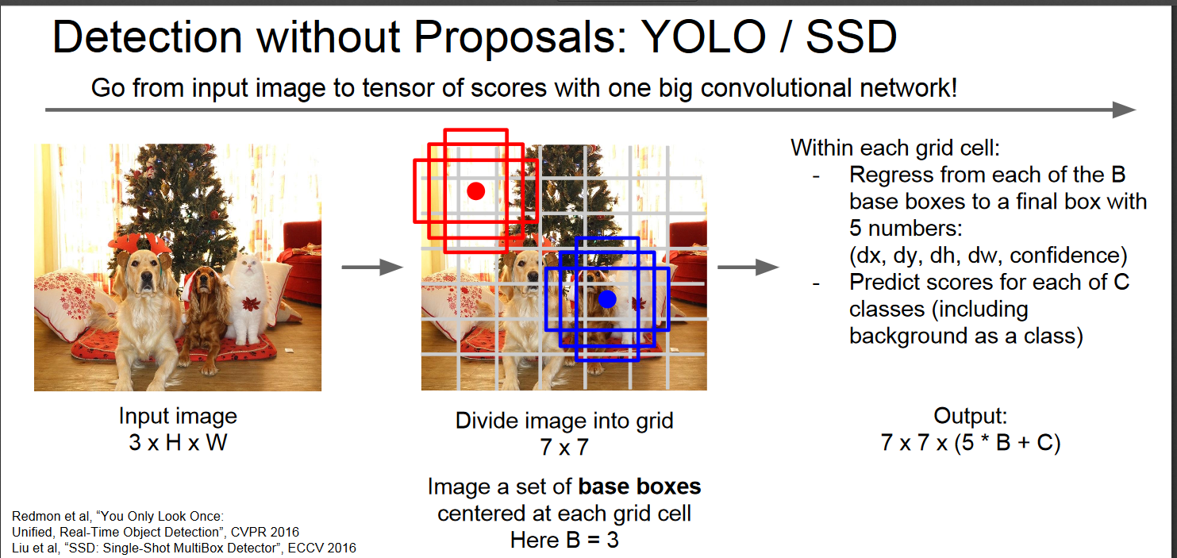

## 4.2 Object detection: speed and accuracy comparison (Faster R-CNN, R-FCN, SSD, FPN, RetinaNet and YOLOv3)

It is very hard to have a fair comparison among different object detectors. There is no straight answer on which model is the best. For real-life applications, we make choices to balance accuracy and speed. Besides the detector types, we need to aware of other choices that impact the performance:

* Feature extractors (VGG16, ResNet, Inception, MobileNet).
* Output strides for the extractor.
* Input image resolutions.
* Matching strategy and IoU threshold (how predictions are excluded in calculating loss).
* Non-max suppression IoU threshold.
* Hard example mining ratio (positive v.s. negative anchor ratio).
* The number of proposals or predictions.
* Boundary box encoding.
* Data augmentation.
* Training dataset.
* Use of multi-scale images in training or testing (with cropping).
* Which feature map layer(s) for object detection.
* Localization loss function.
* Deep learning software platform used.
* Training configurations including batch size, input image resize, learning rate, and learning rate decay.

Worst, the technology evolves so fast that any comparison becomes obsolete quickly. Here, we summarize the results from individual papers so you can view them together. Then we present a survey from Google Research. By presenting multiple viewpoints in one context, we hope that we can understand the performance landscape better.

### 4.2.1 Performance results

In this section, we summarize the performance reported by the corresponding papers

### ****4.2.1.1 Faster R-CNN****

This is the results of PASCAL VOC 2012 test set. We are interested in the last 3 rows representing the Faster R-CNN performance. The second column represents the number of RoIs made by the region proposal network. The third column represents the training dataset used. The fourth column is the mean average precision ([mAP](https://medium.com/@jonathan_hui/map-mean-average-precision-for-object-detection-45c121a31173)) in measuring accuracy.

Results on PASCAL VOC 2012 test set.

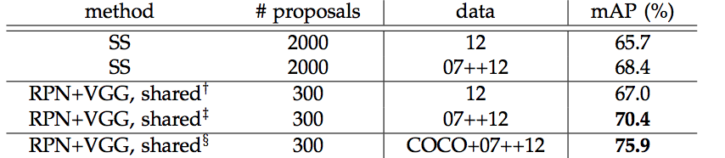

Results on MS COCO.

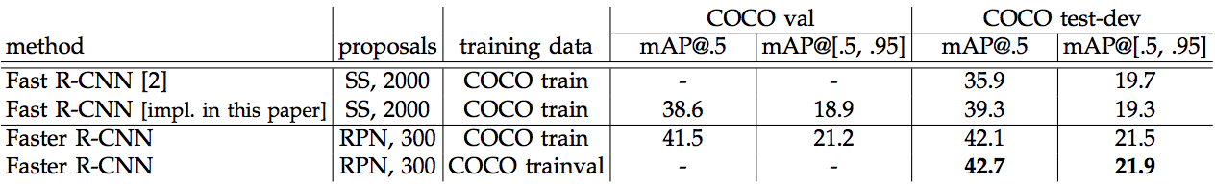

Timing on a K40 GPU in millisecond with PASCAL VOC 2007 test set.

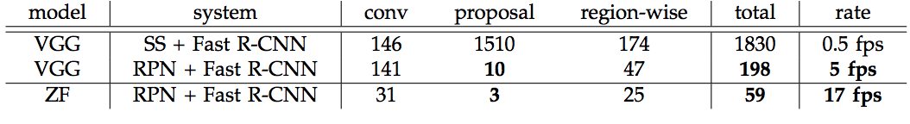

#### ****4.2.1.2 R-FCN****

Results on PASCAL VOC 2012 test set.

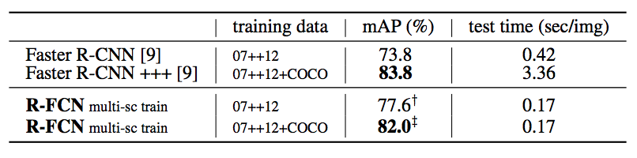

(Multi-scale training and testing are used on some results.)

Results on MS COCO.

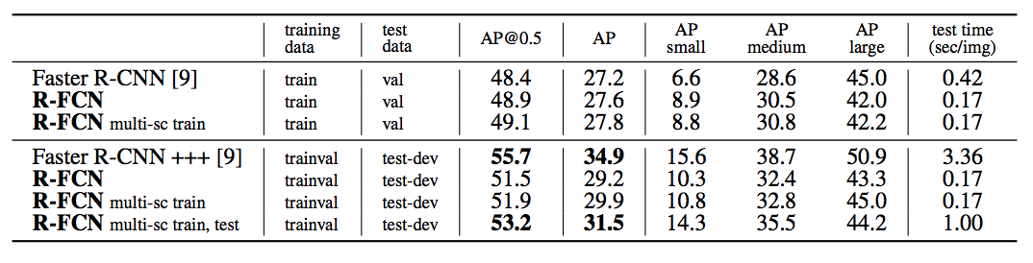

#### ****4.2.1.3 SSD****

This is the results of PASCAL VOC 2007, 2012 and MS COCO using 300 × 300 and 512 × 512 input images.

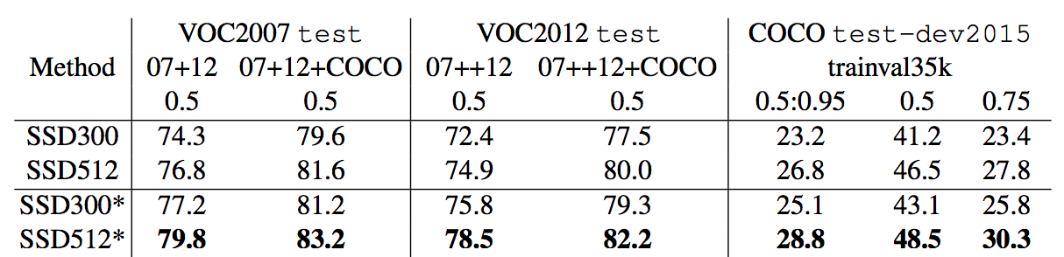

(SSD300* and SSD512* applies data augmentation for small objects to improve mAP.)

Performance:

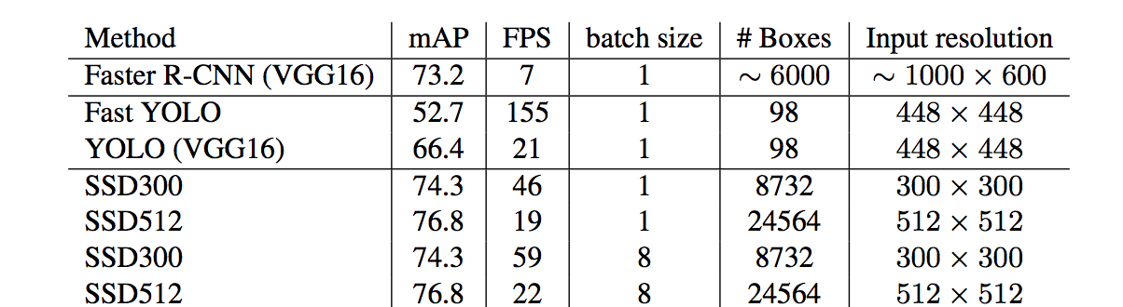

(YOLO here refers to v1 which is slower than YOLOv2 or YOLOv3)

Result on MS COCO:

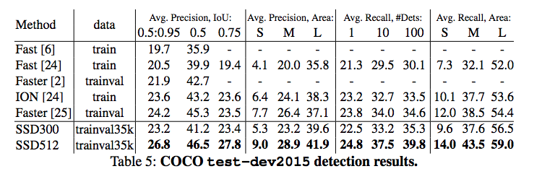

#### ****4.2.1.4 YOLO****

Results on PASCAL VOC 2007 test set.

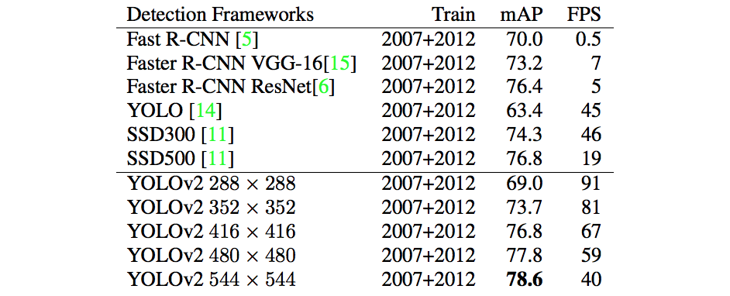

(We add the VOC 2007 test here because it has the results for different image resolutions.)

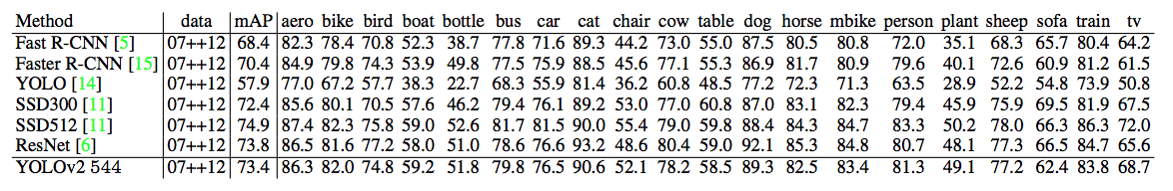Results on PASCAL VOC 2012 test set.

#### ****4.2.1.5 FPN****

Results on MS COCO.

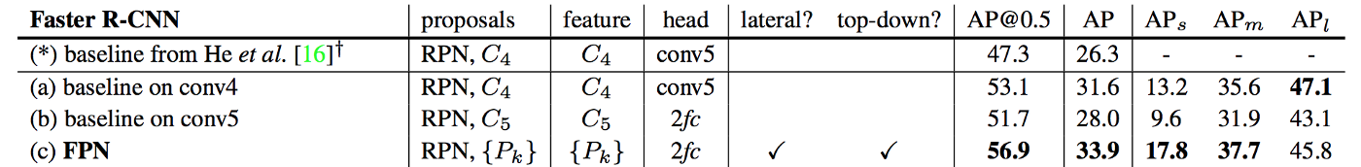

#### ****4.2.1.6 RetinaNet****

Results on MS COCO

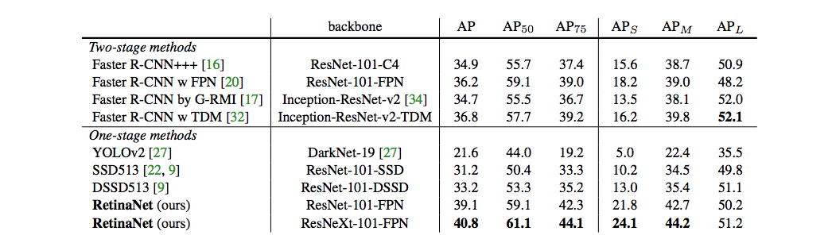

### ****4.2.2 Report**** by Google Research

Google Research offers a survey paper to study the tradeoff between speed and accuracy for Faster R-CNN, R-FCN, and SSD. (The paper does not cover YOLO.) It re-implements those models in TensorFLow using MS COCO dataset for training. It establishes a more controlled environment and makes tradeoff comparison easier. It also introduces MobileNet which achieves high accuracy with much lower complexity.

#### ****4.2.2.1 Speed v.s. accuracy****

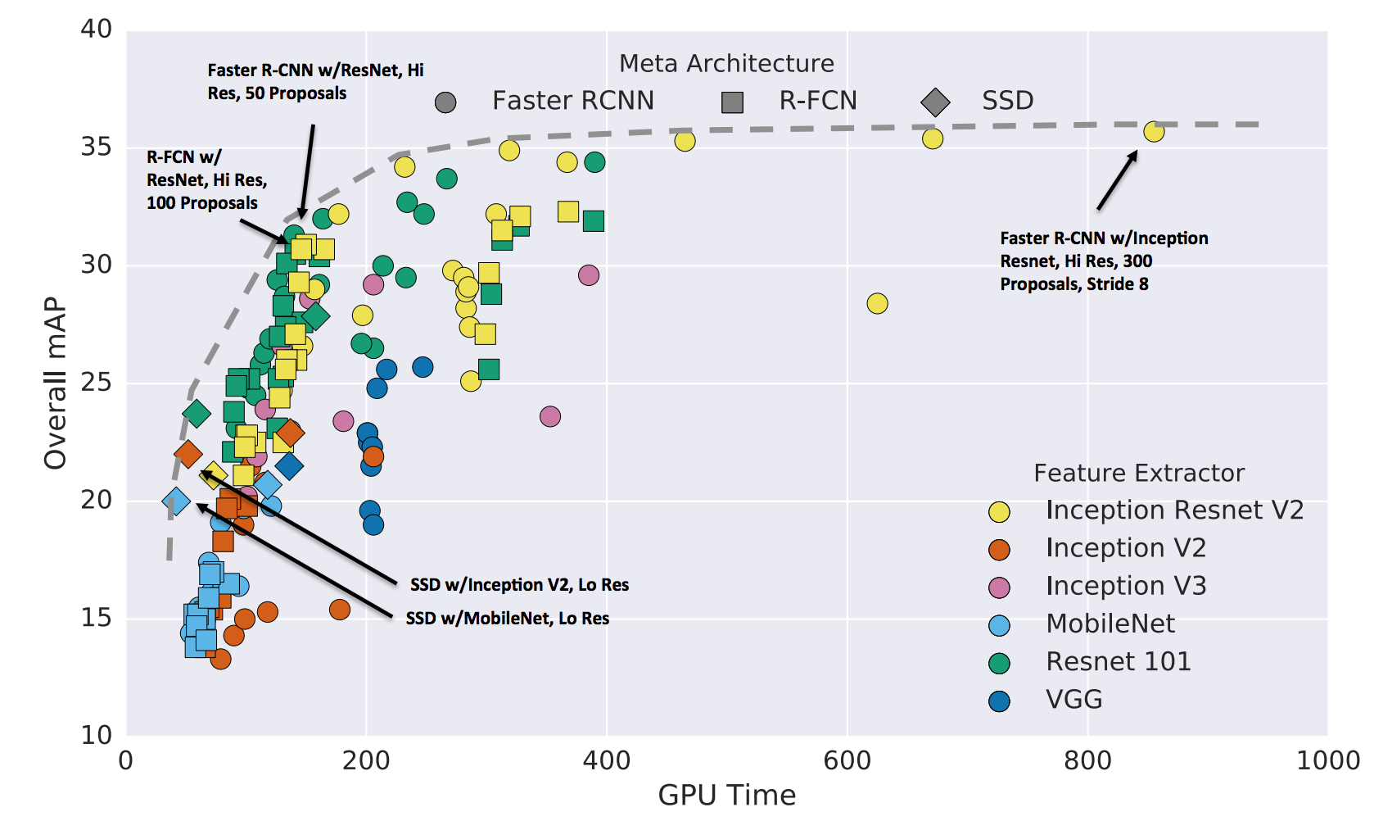The most important question is not which detector is the best. It may not possible to answer. The real question is which detector and what configurations give us the best balance of speed and accuracy that your application needed. Below is the comparison of accuracy v.s. speed tradeoff (time measured in millisecond).

in general, Faster R-CNN is more accurate while R-FCN and SSD are faster.

* Faster R-CNN using Inception Resnet with 300 proposals gives the highest accuracy at 1 FPS for all the tested cases.
* SSD on MobileNet has the highest mAP among the models targeted for real-time processing.

This graph also helps us to locate sweet spots to trade accuracy for good speed return.

* R-FCN models using Residual Network strikes a good balance between accuracy and speed,
* Faster R-CNN with Resnet can attain similar performance if we restrict the number of proposals to 50.

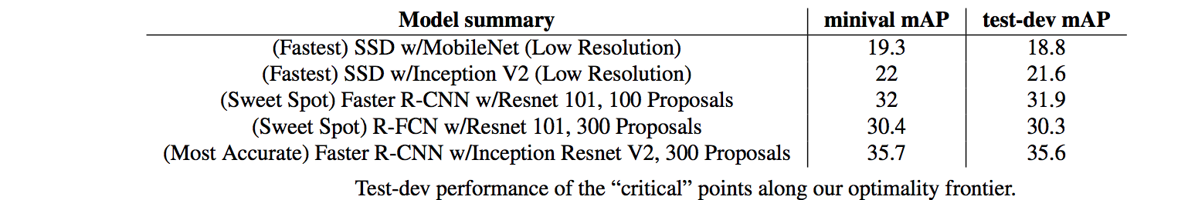

#### ****4.2.2.2 Feature extractor****

The paper studies how the accuracy of the feature extractor impacts the detector accuracy. Both Faster R-CNN and R-FCN can take advantage of a better feature extractor, but it is less significant with SSD.

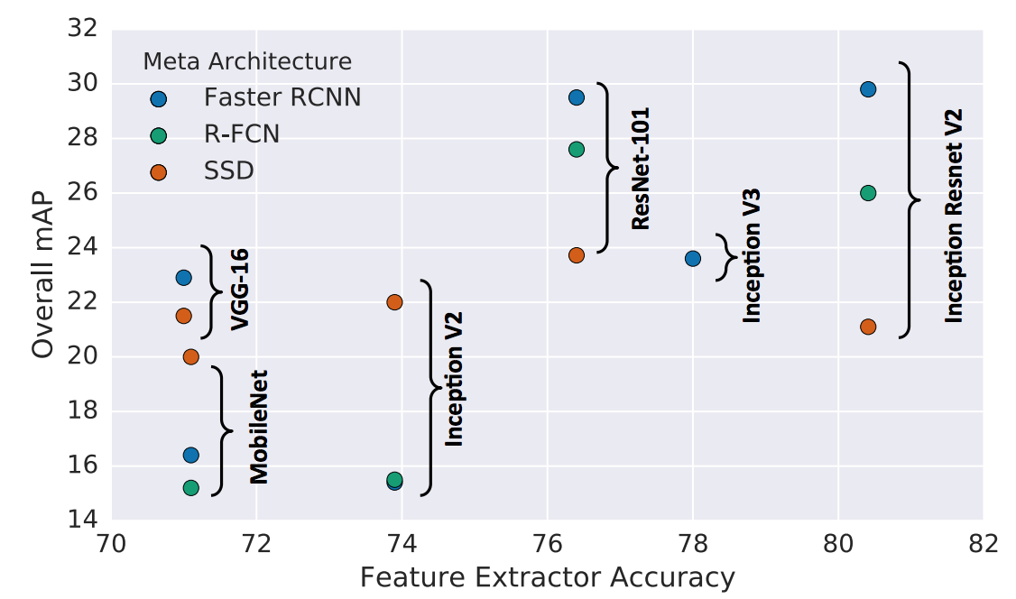

(The x-axis is the top 1% accuracy on classification for each feature extractor.)

#### ****4.2.2.2 Object size****

For large objects, SSD performs pretty well even with a simple extractor. SSD can even match other detectors’ accuracies using better extractor. But SSD performs much worse on **small objects** comparing to other methods.

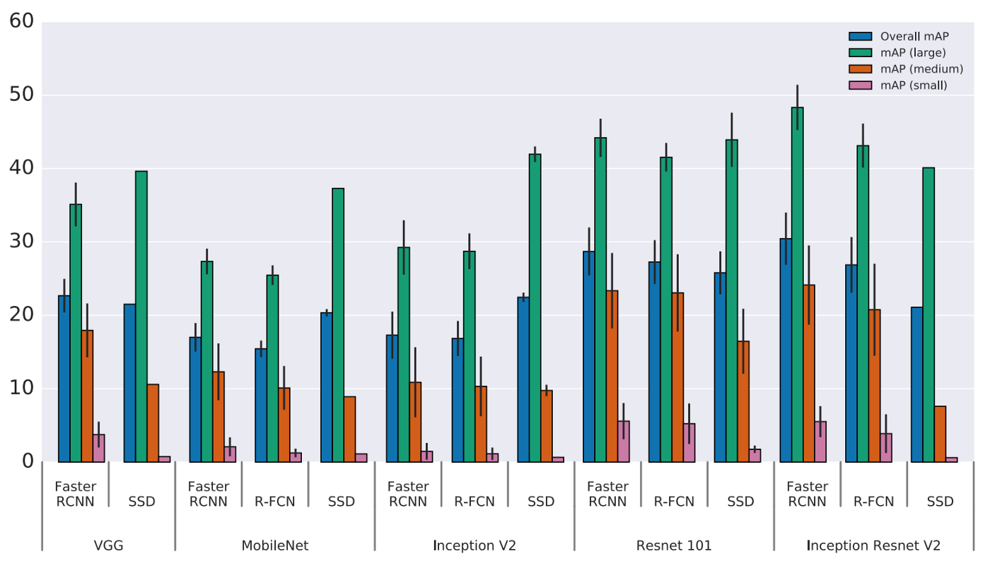

#### ****4.2.2.2 Input image resolution****

Higher resolution improves object detection for small objects significantly while also helping large objects. When decreasing resolution by a factor of two in both dimensions, accuracy is lowered by 15.88% on average but the inference time is also reduced by a factor of 27.4% on average.

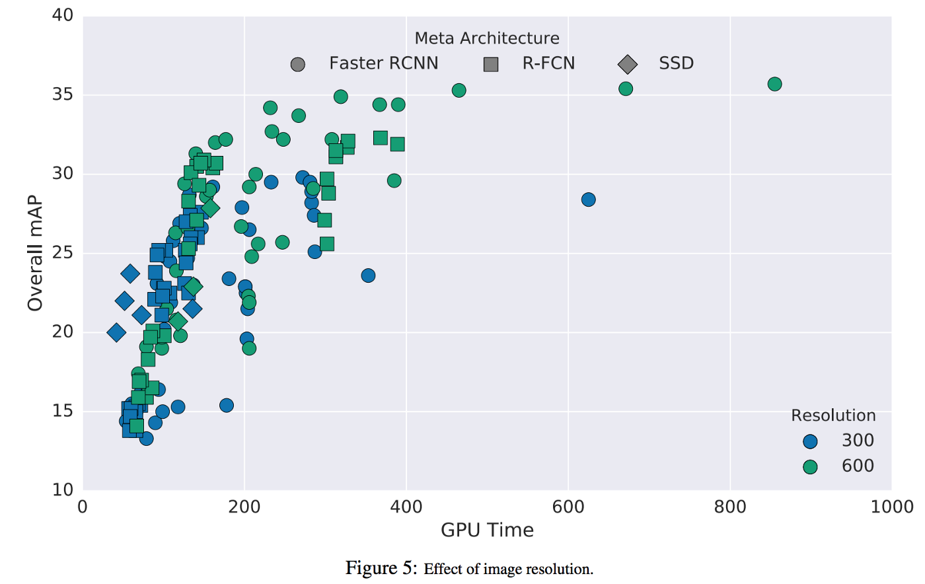

#### ****4.2.2.3 Number of proposals****

The number of proposals generated can impact Faster R-CNN (FRCNN) significantly without a major decrease in accuracy. For example, with Inception Resnet, Faster R-CNN can improve the speed 3x when using 50 proposals instead of 300. The drop in accuracy is just 4% only. Because R-FCN has much less work per ROI, the speed improvement is far less significant.

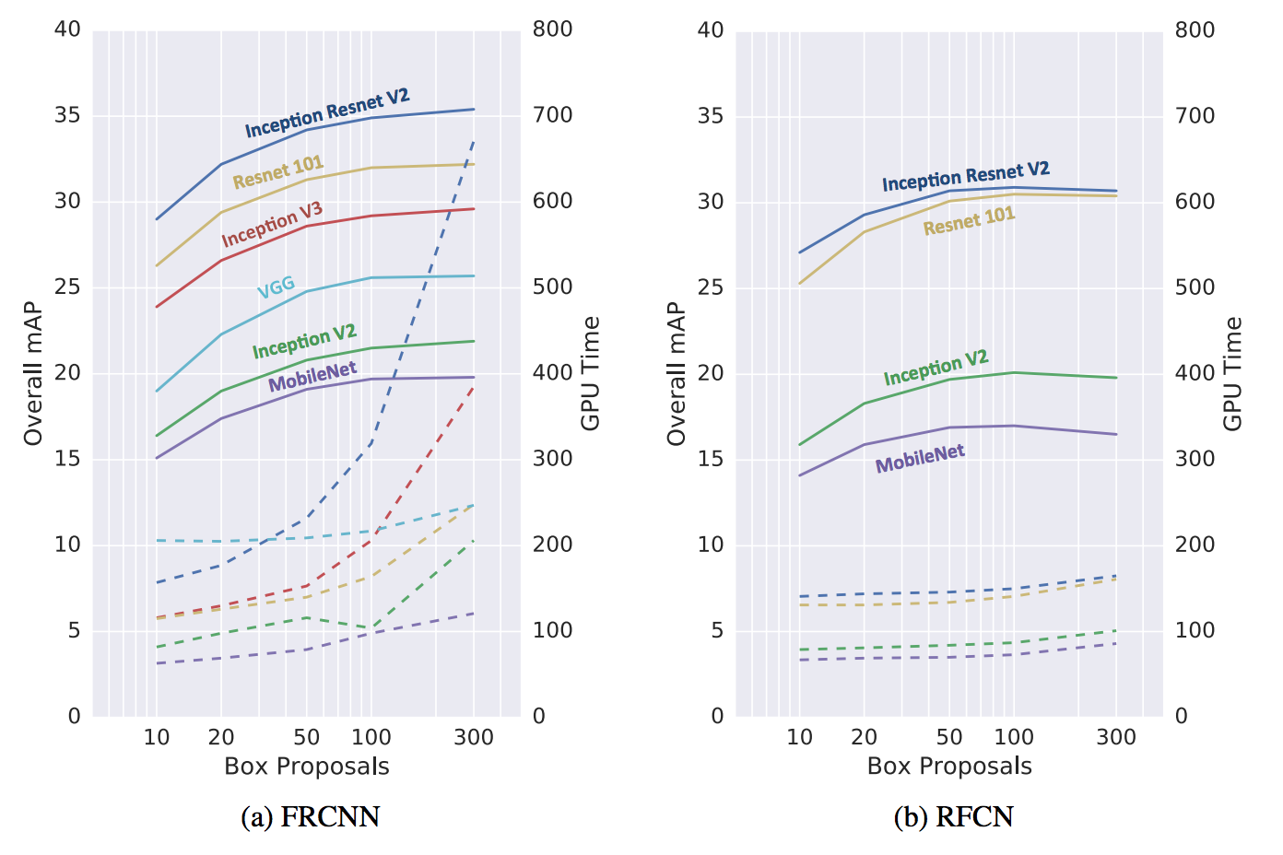

#### ****4.2.2.4 GPU time****

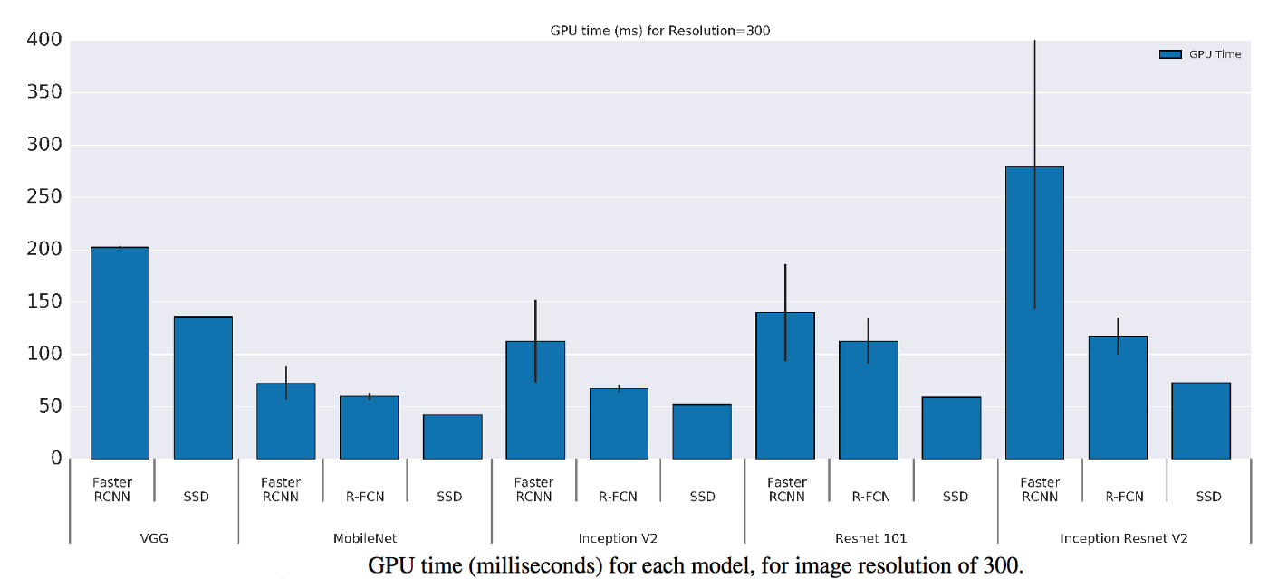Here is the GPU time for different model using different feature extractors.

#### ****4.2.2.5 Memory****

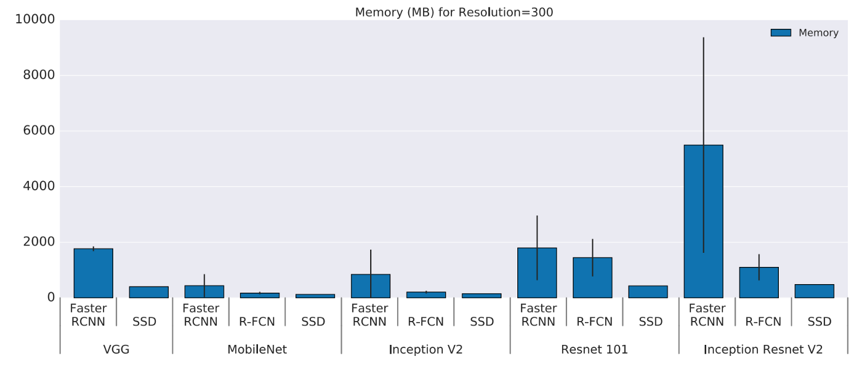MobileNet has the smallest footprint. It requiring less than 1Gb (total) memory.

#### ****4.2.2.6**** Lessons learned

Some key findings from the Google Research paper:

* R-FCN and SSD models are faster on average but cannot beat the Faster R-CNN in accuracy if speed is not a concern.
* Faster R-CNN requires at least 100 ms per image.
* Use only low-resolution feature maps for detections hurts accuracy badly.
* Input image resolution impacts accuracy significantly. Reduce image size by half in width and height lowers accuracy by 15.88% on average but also reduces inference time by 27.4% on average.
* Choice of feature extractors impacts detection accuracy for Faster R-CNN and R-FCN but less reliant for SSD.
* Post processing includes non-max suppression (which only run on CPU) takes up the bulk of the running time for the fastest models at about 40 ms which caps speed to 25 FPS.
* If mAP is calculated with one single IoU only, use mAP@IoU=0.75.
* With an Inception ResNet network as a feature extractor, the use of stride 8 instead of 16 improves the mAP by a factor of 5%, but increased running time by a factor of 63%.

Most accurate

* The most accurate single model use Faster R-CNN using Inception ResNet with 300 proposals. It runs at 1 second per image.
* The most accurate model is an ensemble model with multi-crop inference. It achieves state-of-the-art detection on 2016 COCO challenge in accuracy. It uses the vector of average precision to select five most different models.

Fastest

* SSD with MobileNet provides the best accuracy tradeoff within the fastest detectors.
* SSD is fast but performs worse for small objects comparing with others.
* For large objects, SSD can outperform Faster R-CNN and R-FCN in accuracy with lighter and faster extractors.

Good balance between accuracy and speed

* Faster R-CNN can match the speed of R-FCN and SSD at 32mAP if we reduce the number of proposal to 50.

## 4.3 Faster R-CNN in details

## 4.3.1 Architecture

The architecture of Faster R-CNN is complex because it has several moving parts. We’ll start with a high level overview, and then go over the details for each of the components.

It all starts with an image, from which we want to obtain:

* a list of bounding boxes.
* a label assigned to each bounding box.
* a probability for each label and bounding box.

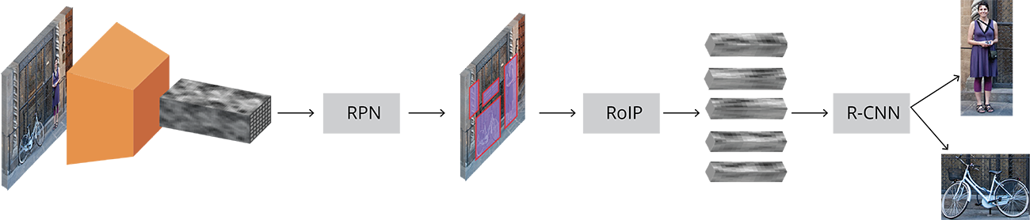

Complete Faster R-CNN architecture

The input images are represented as  **Height×Width×Depth** tensors (multidimensional arrays), which are passed through a pre-trained CNN up until an intermediate layer, ending up with a convolutional feature map. We use this as a feature extractor for the next part.

This technique is very commonly used in the context of Transfer Learning, especially for training a classifier on a small dataset using the weights of a network trained on a bigger dataset. We’ll take a deeper look at this in the following sections.

Next, we have what is called a Region Proposal Network (RPN, for short). Using the features that the CNN computed, it is used to find up to a *predefined number* of regions (bounding boxes), which may contain objects.

Probably the hardest issue with using Deep Learning (DL) for object detection is generating a variable-length list of bounding boxes. When modeling deep neural networks, the last block is usually a fixed sized tensor output (except when using Recurrent Neural Networks( .

For example, in image classification, the output is a (N,) shaped tensor, with N being the number of classes, where each scalar in location i contains the probability of that image being label(​i).

​​

​ The variable-length problem is solved in the RPN by using anchors: fixed sized reference bounding boxes which are placed uniformly throughout the original image. Instead of having to detect where objects are, we model the problem into two parts. For every anchor, we ask:

* Does this anchor contain a relevant object?
* How would we adjust this anchor to better fit the relevant object?

After having a list of possible relevant objects and their locations in the original image, it becomes a more straightforward problem to solve. Using the features extracted by the CNN and the bounding boxes with relevant objects, we apply Region of Interest (RoI) Pooling and extract those features, which would correspond to the relevant objects into a new tensor.

Finally, comes the R-CNN module, which uses that information to:

* Classify the content in the bounding box (or discard it, using “background” as a label).
* Adjust the bounding box coordinates (so it better fits the object).

Obviously, some major bits of information are missing, but that’s basically the general idea of how Faster R-CNN works. Next, we’ll go over the details on both the architecture and loss/training for each of the components.

## 4.3.2 Base network

As we mentioned earlier, the first step is using a CNN pretrained for the task of classification (e.g. using [**ImageNet**](http://www.image-net.org/)) and using the output of an intermediate layer. This may sound really simple for people with a deep learning background, but it’s important to understand how and why it works, as well as visualize what the intermediate layer output looks like.

There is no real consensus on which network architecture is best. The original Faster R-CNN used [**ZF**](https://arxiv.org/abs/1311.2901) and [**VGG**](https://arxiv.org/abs/1409.1556) pretrained on ImageNet but since then there have been lots of different networks with a varying number of weights. For example, [**MobileNet**](https://arxiv.org/abs/1704.04861), a smaller and efficient network architecture optimized for speed, has approximately 3.3M parameters, while ResNet-152 (yes, 152 layers), once the state of the art in the ImageNet classification competition, has around 60M. Most recently, new architectures like [**DenseNet**](https://arxiv.org/abs/1608.06993) are both improving results while lowering the number of parameters.

#### 4.3.2.1 VGG as an example

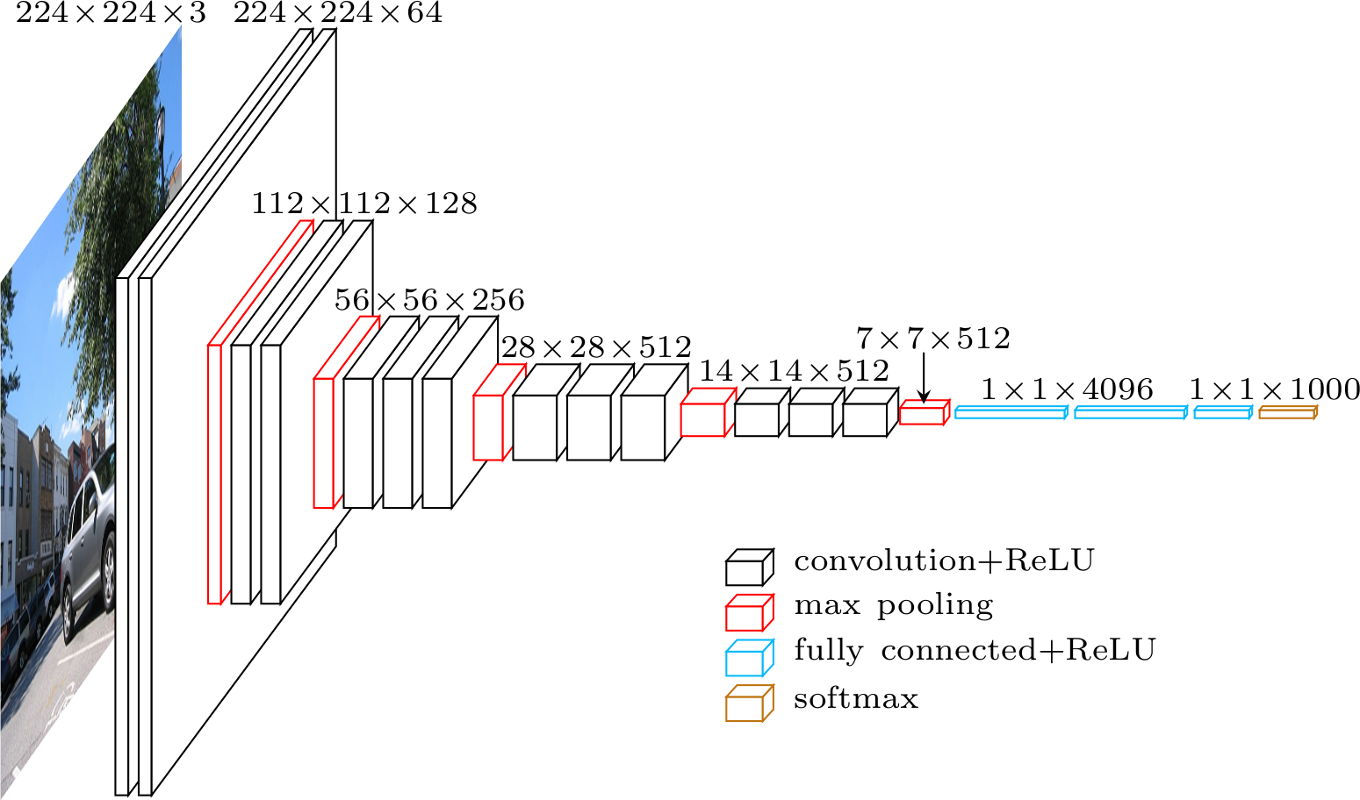

VGG architecture

VGG, whose name comes from the team which used it in the ImageNet ILSVRC 2014 competition, was published in the paper “Very Deep Convolutional Networks for Large-Scale Image Recognition” by [**Karen Simonyan**](http://www.robots.ox.ac.uk/~karen/) and [**Andrew Zisserman**](http://www.robots.ox.ac.uk/~az/). By today’s standards it would not be considered very deep, but at the time it more than doubled the number of layers commonly used and kickstarted the “deeper → more capacity → better” wave (when training is possible).

When using VGG for classification, the input is a 224×224×3 tensor (that means a 224x224 pixel RGB image). This has to remain fixed for classification because the final block of the network uses fully-connected (FC) layers (instead of convolutional), which require a fixed length input. This is usually done by flattening the output of the last convolutional layer, getting a rank 1 tensor, before using the FC layers.

Since we are going to use the output of an intermediate convolutional layer, the size of the input is not our problem. At least, it is not the problem of this module since only convolutional layers are used. Let’s get a bit more into low-level details and define which convolutional layer we are going to use. The paper does not specify which layer to use; but in the official implementation you can see they use the output of **conv5/conv5_1** layer.

Each convolutional layer creates abstractions based on the previous information. The first layers usually learn edges, the second finds patterns in edges in order to activate for more complex shapes and so forth. Eventually we end up with a convolutional feature map which has spatial dimensions much smaller than the original image, but greater depth. The width and height of the feature map decrease because of the pooling applied between convolutional 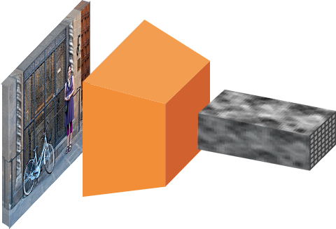layers and the depth increases based on the number of filters the convolutional layer learns.

Image to convolutional feature map

In its depth, the convolutional feature map has encoded all the information for the image while maintaining the location of the “things” it has encoded relative to the original image. For example, if there was a red square on the top left of the image and the convolutional layers activate for it, then the information for that red square would still be on the top left of the convolutional feature map

### 4.3.3 Anchors

Now that we are working with a processed image, we need to find proposals, ie. regions of interest for classification. We previously mentioned that anchors are a way to solve the variable length problem, but we skipped most of the explanation.

Our objective is to find bounding boxes in the image. These have rectangular shape and can come in different sizes and aspect ratios. Imagine we were trying to solve the problem knowing beforehand that there are two objects on the image. The first idea that comes to mind is to train a network that returns 8 values: two  x​min​​,y​min​​,x​max​​,y​max ​​ tuples defining a bounding box for each object. This approach has some fundamental problems. For example, images may have different sizes and aspect ratios, having a good model trained to predict raw coordinates can turn out to be very complicated (if not impossible). Another problem is invalid predictions: when predicting X​min​​ and X​max​​ we have to somehow enforce that  X​min​​ < X​max​​.

It turns out that there is a simpler approach to predicting bounding boxes by learning to predict offsets from reference boxes. We take a reference box  x​center​​,Ycenter​​ ,width ,height and learn to predict  Δ​x​center​​​​,Δ​y​center​​​​,Δ​width​​,Δ​height​​, which are usually small values that tweak the reference box to better fit what we want.

Anchors are fixed bounding boxes that are placed throughout the image with different sizes and ratios that are going to be used for reference when first predicting object locations.

Since we are working with a convolutional feature map of size  conv​-width​​× conv​-height​​ × conv- ​depth​​, we create a set of anchors for each of the points conv​-width​​×conv-​height​​. It’s important to understand that even though anchors are defined based on the convolutional feature map, the final anchors reference the original image.

Since we only have convolutional and pooling layers, the dimensions of the feature map will be proportional to those of the original image. Mathematically, if the image was  w×h, the feature map will end up  w/r × h/r  where r is called subsampling ratio. If we define one anchor per spatial position of the feature map, the final image will end up with a bunch of anchors separated by r pixels. In the case of VGG, r = 16*.*

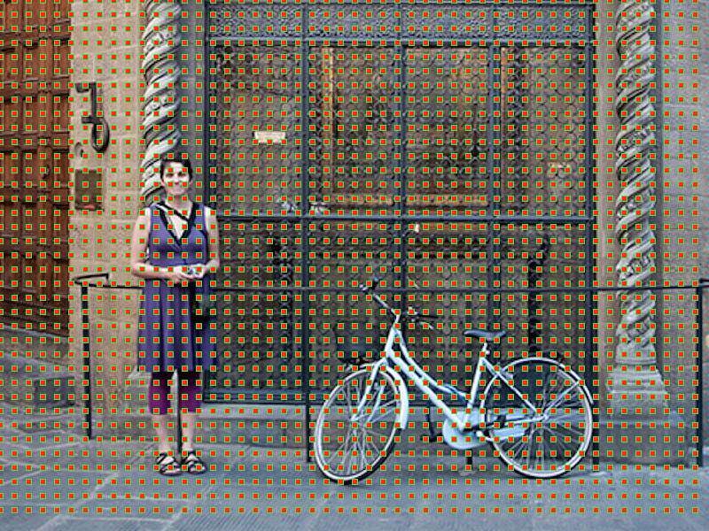

Anchor centers through the original image

In order to choose the set of anchors we usually define a set of sizes (e.g. 64px, 128px, 256px) and a set of ratios between width and height of boxes (e.g. 0.5, 1, 1.5) and use all the possible combinations of sizes and ratios.

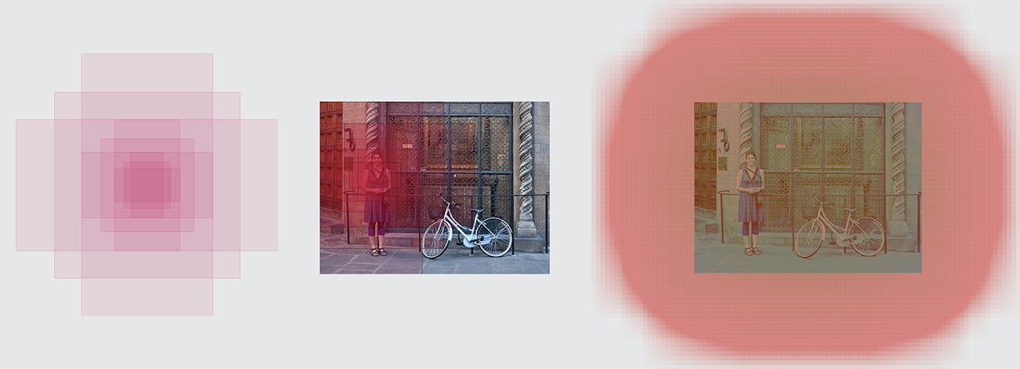

Left: Anchors, Center: Anchor for a single point, Right: All anchors

### 4.3.4 Region Proposal Network

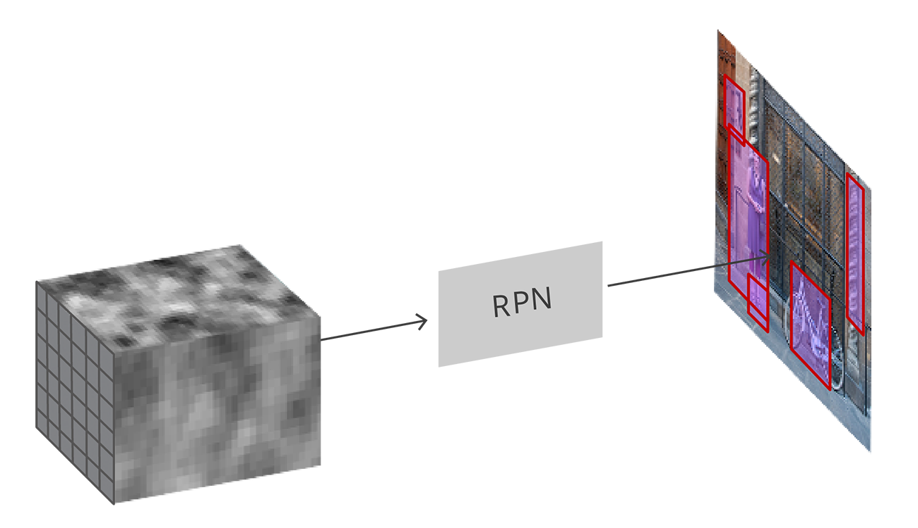

The RPN takes the convolutional feature map and generates proposals over the image

As we mentioned before, the RPN takes all the reference boxes (anchors) and outputs a set of good proposals for objects. It does this by having two different outputs for each of the anchors.

The first one is the probability that an anchor is an object. An ‘objectness score’, if you will. Note that the RPN doesn’t care what class of object it is, only that it does in fact look like an object (and not background). We are going to use this objectness score to filter out the bad predictions for the second stage. The second output is the bounding box regression for adjusting the anchors to better fit the object it’s predicting.

The RPN is implemented efficiently in a fully convolutional way, using the convolutional feature map returned by the base network as an input. First, we use a convolutional layer with 512 channels and 3x3 kernel size and then we have two parallel convolutional layers using a 1x1 kernel, whose number of channels depends on the number of anchors per point.

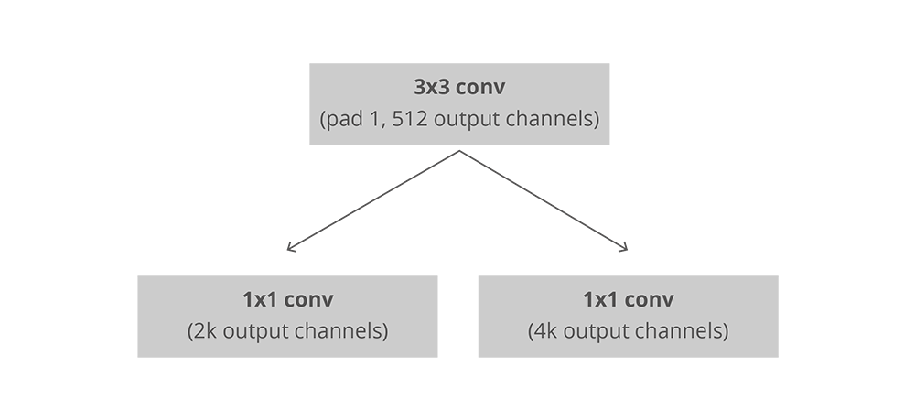

Convolutional implementation of an RPN architecture, where k is the number of anchors.

For the classification layer, we output two predictions per anchor: the score of it being background (not an object) and the score of it being foreground (an actual object).

For the regression, or bounding box adjustment layer, we output 4 predictions: the deltas

Δ​*x*​*center*​​​​,Δ​*y*​*center*​​​​,Δ​*width*​​,Δ​*height*​​ which we will apply to the anchors to get the final proposals.

Using the final proposal coordinates and their ‘objectness’ score we then have a good set of proposals for objects.

### 4.3.5 Training, target and loss functions

The RPN does two different type of predictions: the binary classification and the bounding box regression adjustment.

For training, we take all the anchors and put them into two different categories. Those that overlap a ground-truth object with an Intersection over Union (IoU) bigger than 0.5 are considered “foreground” and those that don’t overlap any ground truth object or have less than 0.1 IoU with ground-truth objects are considered ‘background’.

Then, we randomly sample those anchors to form a mini batch of size 256 — trying to maintain a balanced ratio between foreground and background anchors.

The RPN uses all the anchors selected for the mini batch to calculate the classification loss using binary cross entropy. Then, it uses only those minibatch anchors marked as foreground to calculate the regression loss. For calculating the targets for the regression, we use the foreground anchor and the closest ground truth object and calculate the correct Δ needed to transform the anchor into the object.

Instead of using a simple L1 or L2 loss for the regression error, the paper suggests using Smooth L1 loss. Smooth L1 is L1, but when the L1 error is small enough, defined by a certain σ, the error is considered almost correct and the loss diminishes at a faster rate.

Using dynamic batches can be challenging for a number of reasons. Even though we try to maintain a balanced ratio between anchors that are considered background and those that are considered foreground that is not always possible. Depending on the ground truth objects in the image and the size and ratios of the anchors, it is possible to end up with zero foreground anchors. In those cases, we turn to using the anchors with the biggest IoU to the ground truth boxes. This is far from ideal, but practical in the sense that we always have foreground samples and targets to learn from

### 4.3.6 Post processing

Non-maximum suppression since anchors usually overlap, proposals end up also overlapping over the same object. To solve the issue of duplicate proposals we use a simple algorithmic approach called Non-Maximum Suppression (NMS). NMS takes the list of proposals sorted by score and iterates over the sorted list, discarding those proposals that have an IoU larger than some predefined threshold with a proposal that has a higher score.

While this looks simple, it is very important to be cautious with the IoU threshold. Too low and you may end up missing proposals for objects; too high and you could end up with too many proposals for the same object. A value commonly used is 0.6.

Proposal selection after applying NMS, we keep the top N proposals sorted by score. In the paper N=2000N=2000 is used, but it is possible to lower that number to as little as 50 and still get quite good results

### 4.3.7 Region of Interest Pooling

After the RPN step, we have a bunch of object proposals with no class assigned to them. Our next problem to solve is how to take these bounding boxes and classify them into our desired categories.

The simplest approach would be to take each proposal, crop it, and then pass it through the pre-trained base network. Then, we can use the extracted features as input for a vanilla image classifier. The main problem is that running the computations for all the 2000 proposals is really inefficient and slow.

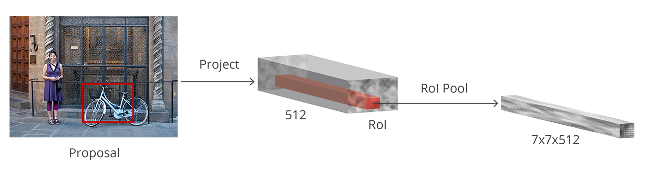Faster R-CNN tries to solve, or at least mitigate, this problem by reusing the existing convolutional feature map. This is done by extracting fixed-sized feature maps for each proposal-using region of interest pooling. Fixed size feature maps are needed for the R-CNN in order to classify them into a fixed number of classes.

Region of Interest Pooling

A simpler method, which is widely used by object detection implementations, including Luminoth’s Faster R-CNN, is to crop the convolutional feature map using each proposal and then resize each crop to a fixed sized 14×14×convdepth using interpolation (usually bilinear). After cropping, max pooling with a 2x2 kernel is used to get a final 7×7×convdepth feature map for each proposal.

The reason for choosing those exact shapes is related to how it is used next by the next block (R-CNN). It is important to understand that those are customizable depending on the second stage use.

### 4.3.8 Region-based Convolutional Neural Network

Region-based convolutional neural network (R-CNN) is the final step in Faster R-CNN’s pipeline. After getting a convolutional feature map from the image, using it to get object proposals with the RPN and finally extracting features for each of those proposals (via RoI Pooling), we finally need to use these features for classification. R-CNN tries to mimic the final stages of classification CNNs where a fully-connected layer is used to output a score for each possible object class.

R-CNN has two different goals:

1. Classify proposals into one of the classes, plus a background class (for removing bad proposals).
2. Better adjust the bounding box for the proposal according to the predicted class.

In the original Faster R-CNN paper, the R-CNN takes the feature map for each proposal, flattens it and uses two fully-connected layers of size 4096 with ReLU activation.

Then, it uses two different fully-connected layers for each of the different objects:

* A fully-connected layer with N+1units where N is the total number of classes and that extra one is for the background class.
* 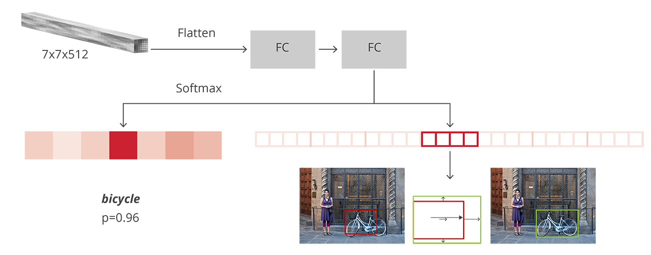A fully-connected layer with 4N units. We want to have a regression prediction, thus we need Δ​*center*​*x*​​​​,Δ​*center*​*y*​​​​,Δ​*width*​​,Δ​*height*​​ for each of the N possible classes.

R-CNN architecture

### 4.3.8 Training and targets

Targets for R-CNN are calculated in almost the same way as the RPN targets, but taking into account the different possible classes. We take the proposals and the ground-truth boxes, and calculate the IoU between them.

Those proposals that have a IoU greater than 0.5 with any ground truth box get assigned to that ground truth. Those that have between 0.1 and 0.5 get labeled as background. Contrary to what we did while assembling targets for the RPN, we ignore proposals without any intersection. This is because at this stage we are assuming that we have good proposals and we are more interested in solving the harder cases. Of course, all these values are hyperparameters that can be tuned to better fit the type of objects that you are trying to find.

The targets for the bounding box regression are calculated as the offset between the proposal and its corresponding ground-truth box, only for those proposals that have been assigned a class based on the IoU threshold.

We randomly sample a balanced mini batch of size 64 in which we have up to 25% foreground proposals (with class) and 75% background.

Following the same path as we did for the RPNs losses, the classification loss is now a multiclass cross entropy loss, using all the selected proposals and the Smooth L1 loss for the 25% proposals that are matched to a ground truth box. We have to be careful when getting that loss since the output of the R-CNN fully connected network for bounding box regressions has one prediction for each of the classes. When calculating the loss, we only have to take into account the one for the correct class

### 4.3.9 Post processing

Similar to the RPN, we end up with a bunch of objects with classes assigned which need further processing before returning them.

In order to apply the bounding box adjustments we have to take into account, which is the class with the highest probability for that proposal. We also have to ignore those proposals that have the background class as the one with the highest probability.

After getting the final objects and ignoring those predicted as background, we apply class-based NMS. This is done by grouping the objects by class, sorting them by probability and then applying NMS to each independent group before joining them again.

For our final list of objects, we also can set a probability threshold and a limit on the number of objects for each class

### 4.3.10 Training

In the original paper, Faster R-CNN was trained using a multi-step approach, training parts independently and merging the trained weights before a final full training approach. Since then, it has been found that doing end-to-end, joint training leads to better results.

After putting the complete model together we end up with 4 different losses, two for the RPN and two for R-CNN. We have the trainable layers in RPN and R-CNN, and we also have the base network which we can train (fine-tune) or not.

The decision to train the base network depends on the nature of the objects we want to learn and the computing power available. If we want to detect objects that are similar to those that were on the original dataset on which the base network was trained on, then there is no real need except for trying to squeeze all the possible performance we can get. On the other hand, training the base network can be expensive both in time and on the necessary hardware, to be able to fit the complete gradients.

The four different losses are combined using a weighted sum. This is because we may want to give classification losses more weight relative to regression ones, or maybe give R-CNN losses more power over the RPNs’.

Apart from the regular losses, we also have the regularization losses which we skipped for the sake of brevity but can be defined both in RPN and in R-CNN. We use L2 regularization for some of the layers and depending on which base network being used and if it’s trained, it may also have regularization.

We train using Stochastic Gradient Descent with momentum, setting the momentum value to 0.9. You can easily train Faster R-CNN with any other optimizer without bumping into any big problem.

The learning rate starts at 0.0010.001 and then decreases to 0.00010.0001 after 50K steps. This is one of the hyperparameters that usually matters the most. When training with Luminoth, we usually start with the defaults and tune it from then on.

### 4.3.11 Evaluation

The evaluation is done using the standard Mean Average Precision (mAP) at some specific IoU threshold (e.g. mAP@0.5). mAP is a metric that comes from information retrieval, and is commonly used for calculating the error in ranking problems and for evaluating object detection problems.

We will not go into details since these type of metrics deserve a blogpost of their own, but the important takeaway is that mAP penalizes you when you miss a box that you should have detected, as well as when you detect something that does not exist or detect the same thing multiple times.

## 4.4 Tensorflow Object Detection API

We used tenforflow object detection api. It provides a Meta architecture .This Meta architecture has general tensorflow implementation of Faster R-CNN detection models. To build your own model you have to reimplement the following functions :

def preprocess(self, resized_inputs)

def extract_proposal_features(self, preprocessed_inputs, scope)

def extract_box_classifier_features(self, proposal_feature_maps, scope)

def restore_from_classification_checkpoint_fn(self,first_stage_feature_extractor_scope,second_stage_feature_extractor_scope)

you can also change the parameters from the congif file